# CS 255 System Design Document

KaLee Li

## UML Diagrams

### UML Use Case Diagram

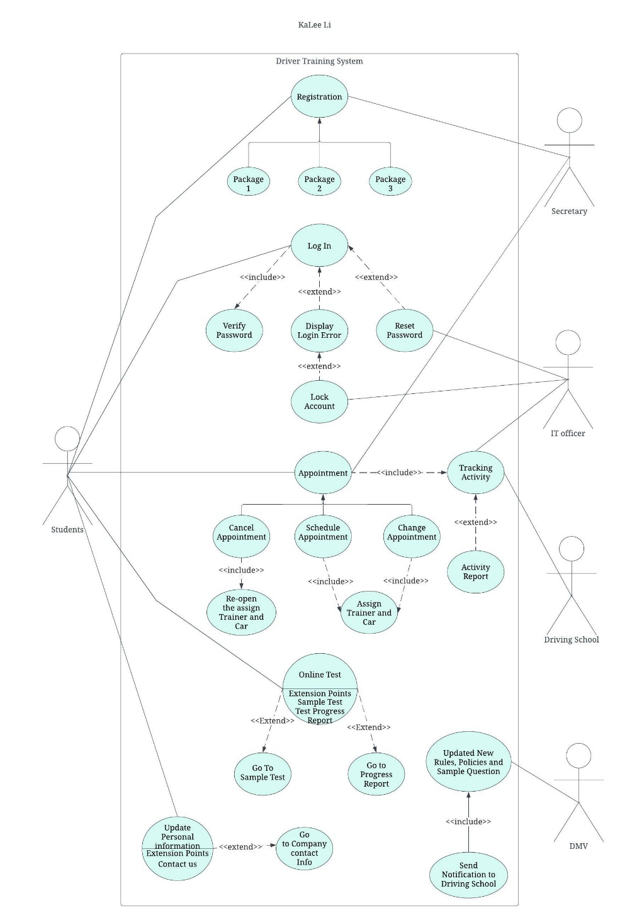

### UML Activity Diagrams

*I was asked to choose* ***two*** *use cases and create* ***two*** *activity diagrams, one for each use case. First activity diagram is based on log in use case. Second activity diagram is based on Appointment use case.*

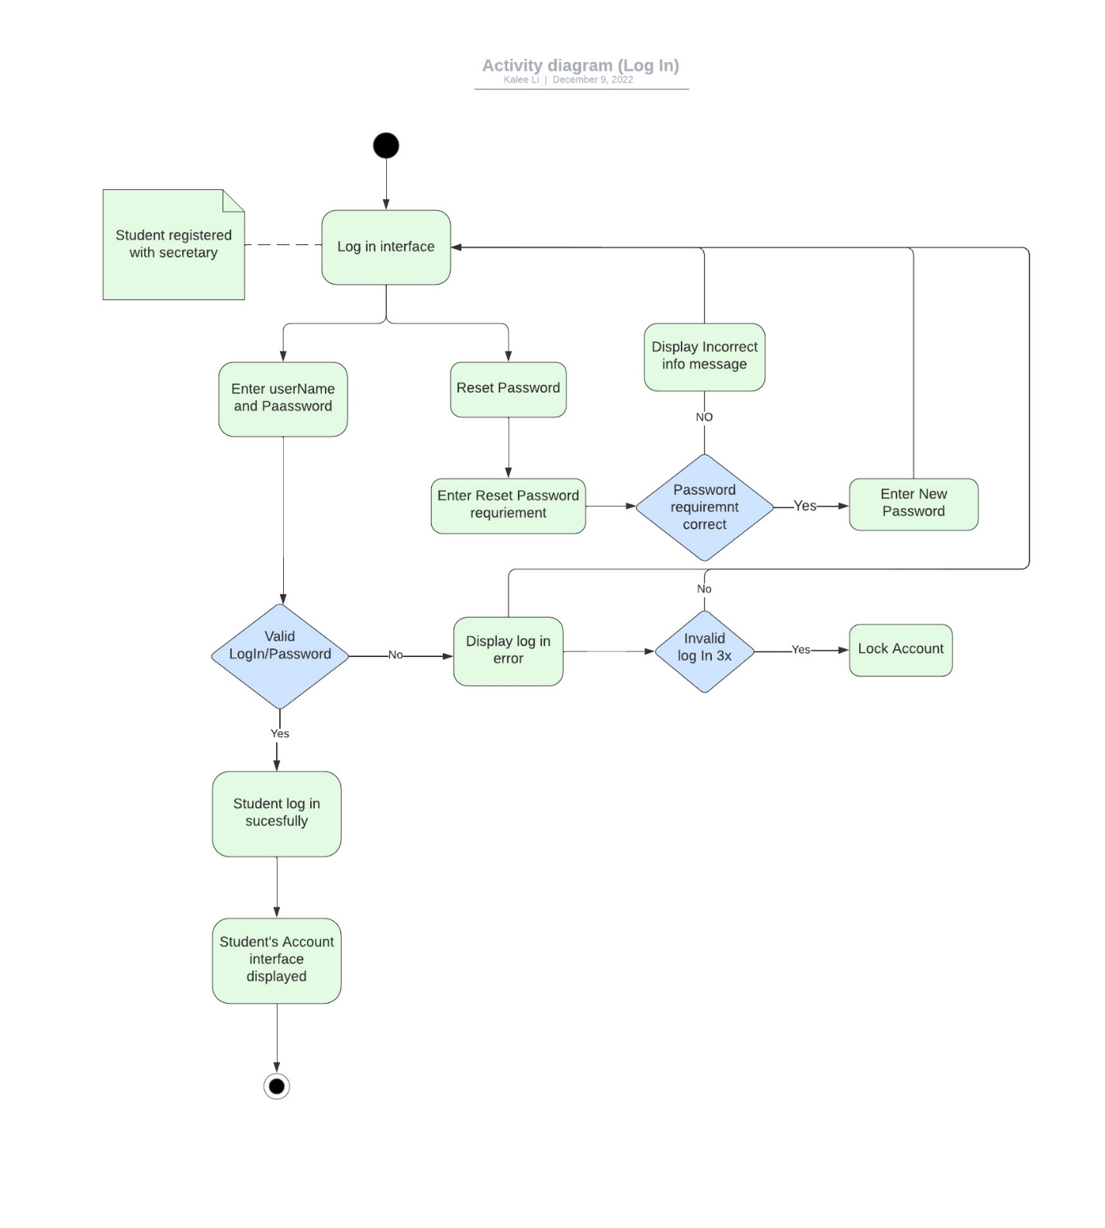

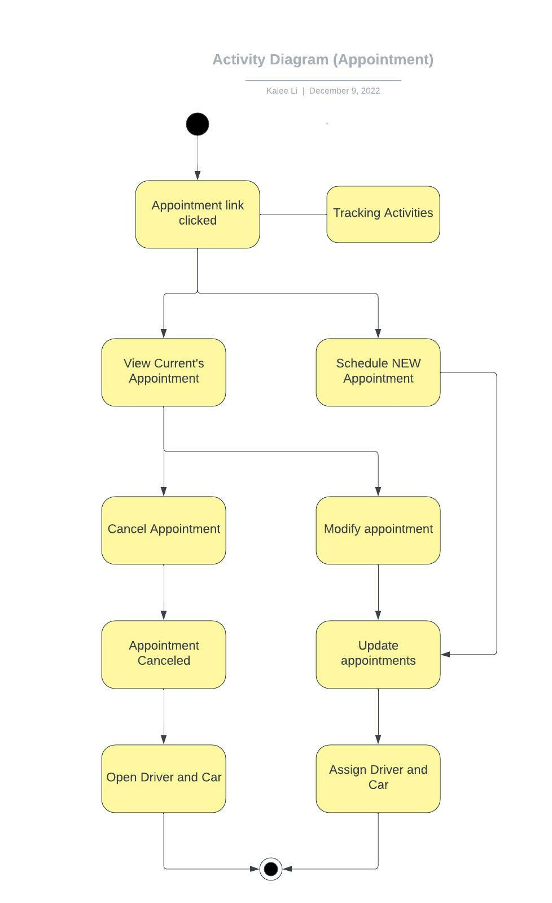

### UML Sequence Diagram

*I was asked to create a sequence diagram based on* ***one*** *of the use cases you chose. This diagram is based on registration use case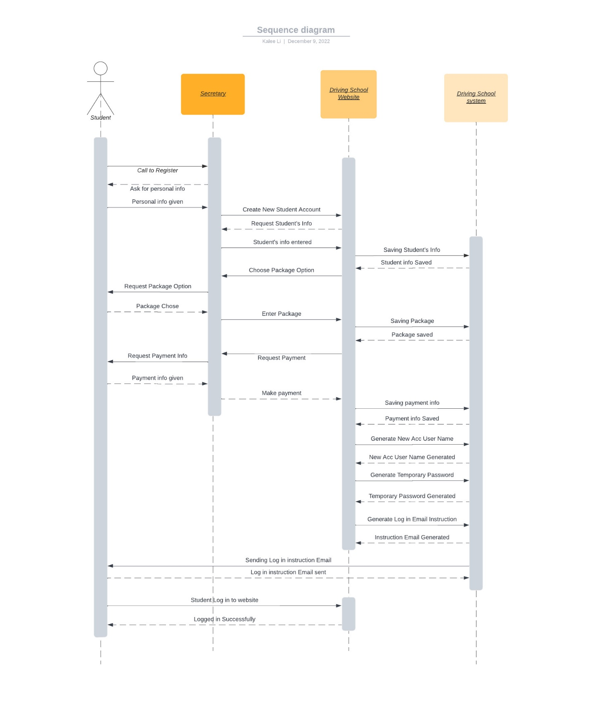*

### UML Class Diagram

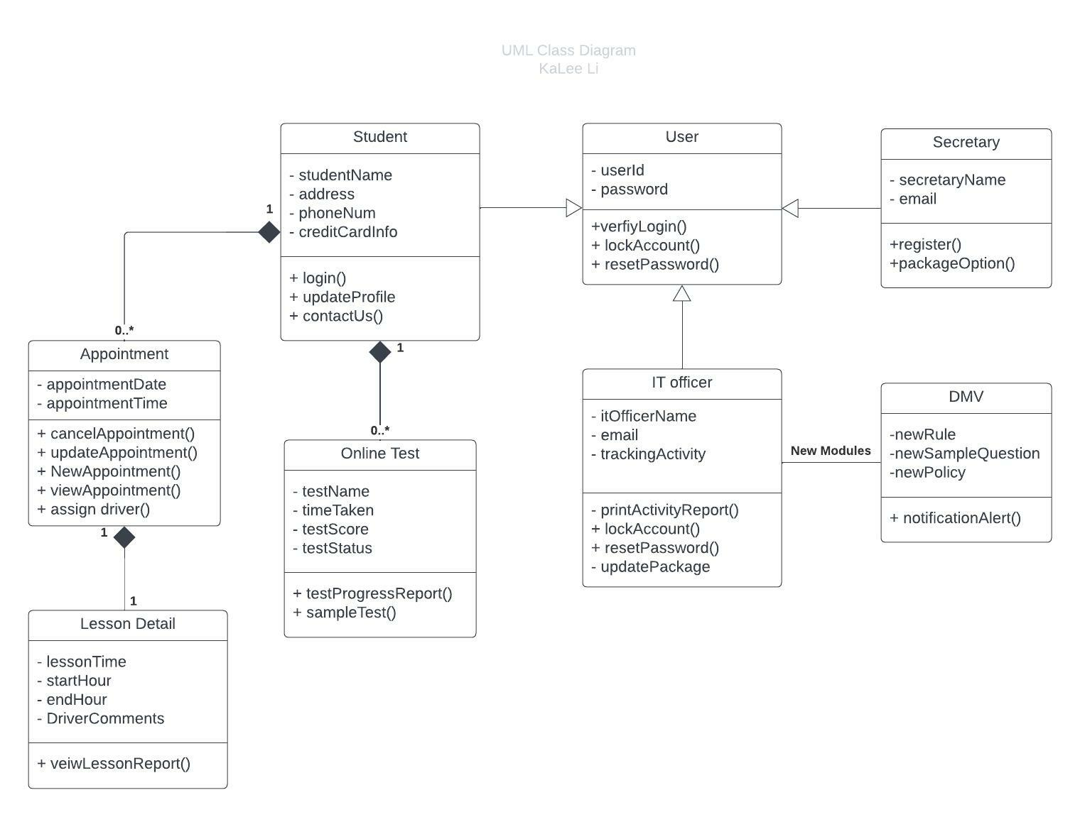

## Technical Requirements

* A developer or a system analyst to add or remove the module when DMV release new rules, policies, or sample question.
* The system needs to run off the web over the cloud. Therefore, we will need to seek a web host.
* The users will need internet to access the system
* The system needs to be accessible from a computer or mobile device